Level 0

The goal of this level is to log into the game using SSH.

SSH stands for Secure shell or Secure socket shell. SSH is a network protocol that provides the user to access the remote server or computer over an un secured network. It provides the encrypted data communication between the computers.

Windows doesn’t provide a built-in SSH command. So for connecting to the SSH server (in our case Login to the Bandit wargame) we need third party application called Putty. We can easily download and install Pully in our windows system from <https://www.putty.org/> . Now we are ready to launch putty tool.

* Enter the host name and port number.
* Click on the “Open” option.

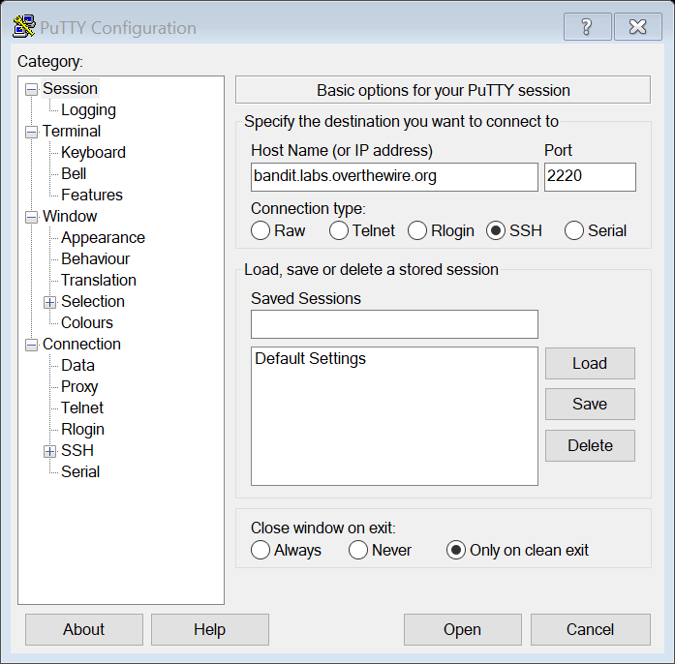

* Enter login ID :- bandit0 , password :- bandit0

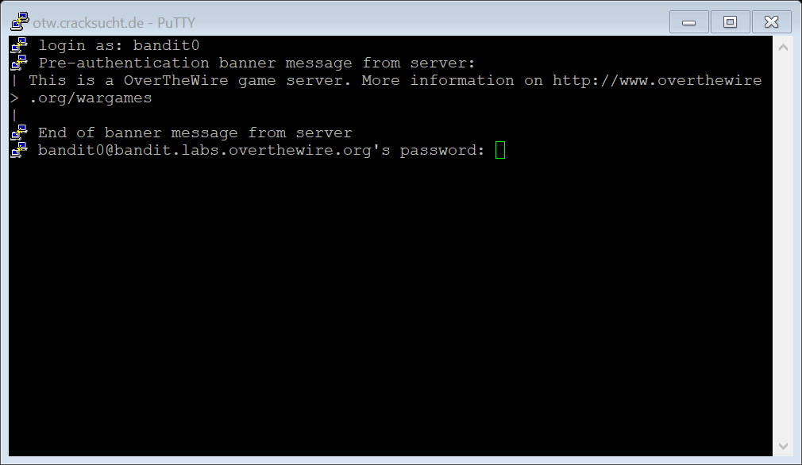

* Press enter.

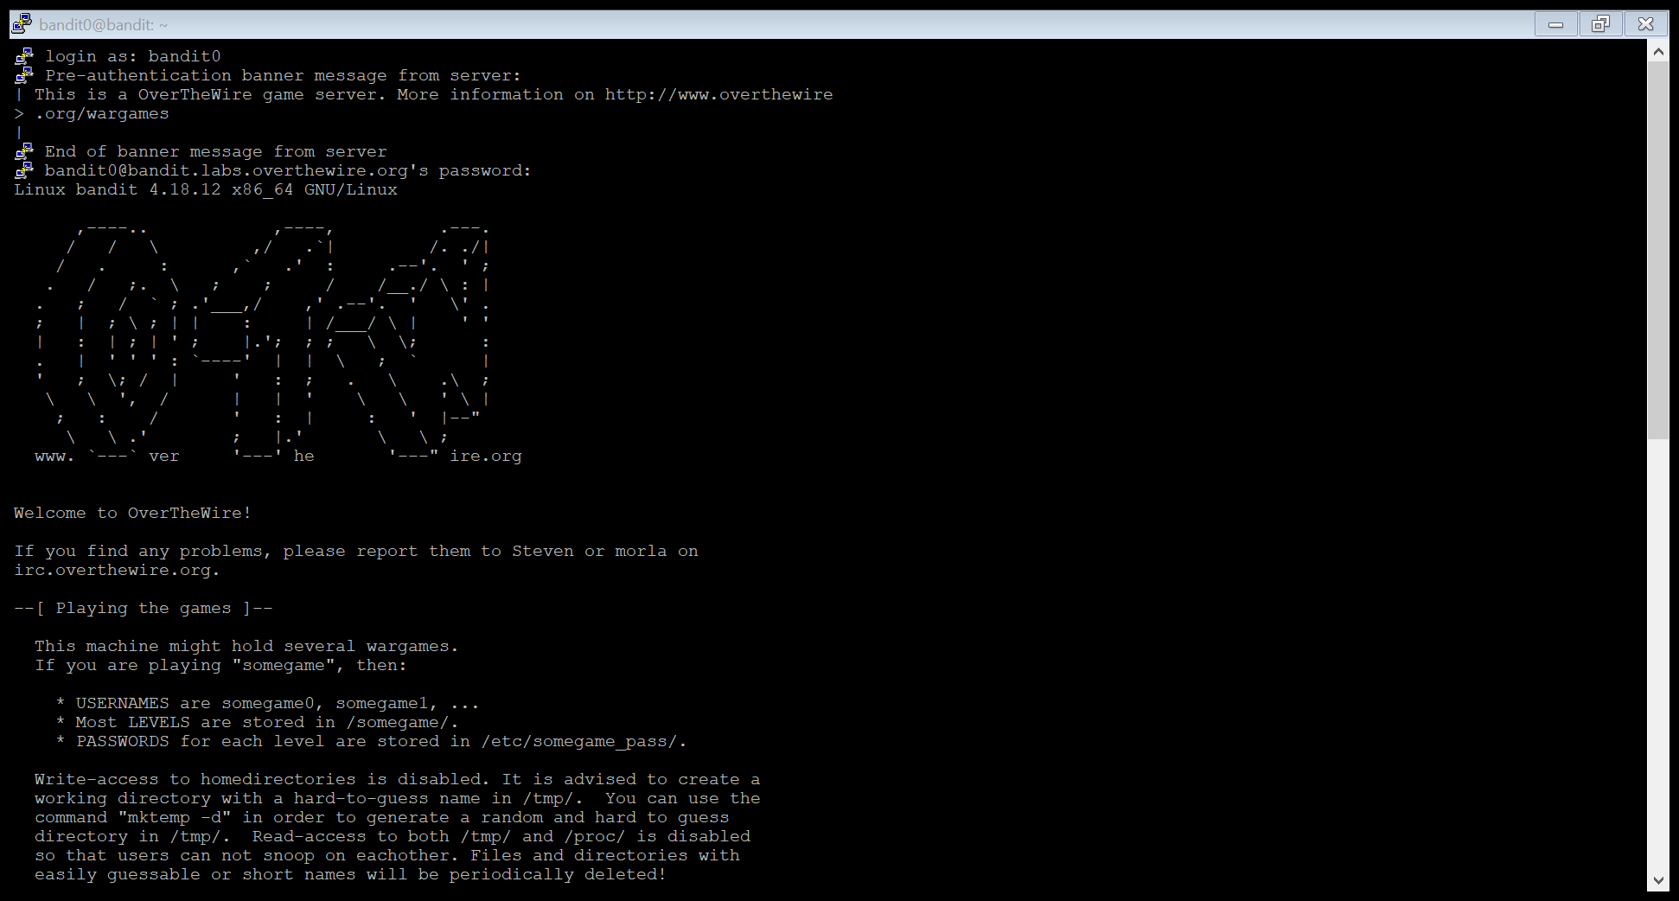

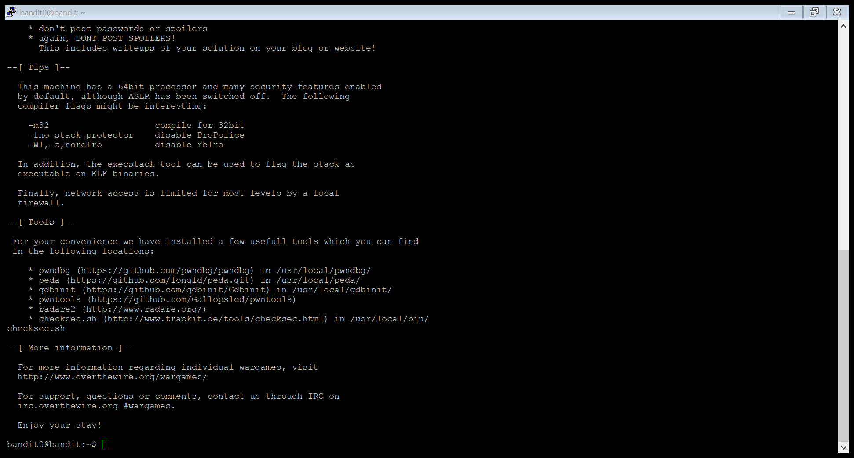

Yeah!!!!! We are logged in Successfully…